Olly de Boer July 10 , 2025

2017 general ELECTION

ANALYSIS

# Executive summary

The results of the 2017 General Election have been detailed into a dataset (uk_election_data_v2.csv, which can be found in Election Analysis\Raw Data). Using this raw dataset, I have conducted my own analysis and breakdown of the results using Structured Query Language (SQL) and Visualisation Software (Tableau). The objective is to showcase some of the key findings and translate them to a general audience.

The additional aim is to showcase my (the author’s) ability to analyse data, think creatively, and also use programming tools (PostgreSQL) in different ways. I am confident in SQL, Python, Excel, and also Tablau/PowerBi. I love data, and believe I have the skills and desire to work in the sector.

# Research Questions

The following research questions that this document will be answering are:

* Who won the most seats in the 2017 General Election and who are the biggest parties?
* How well was the performance of each party in constituencies that voted Remain and Leave During the 2016 Brexit Referendum?
* What were the major party’s Top 5 largest majorities?
* What were the closest constituency majorities?

# SQL queries

A copy of all of the SQL queires used can be found within the Markdown document “Election Analysis SQL Queries” within the queries folder “Data Analysis\Election Analysis\Queries” on GithHub. There is a mix of Window queries, Common Table Expressions, Nested and Subqueries. I love SQL and hope to get bettter in the future in a role...

### **Research Question 1: Seat Distribution in the 2017 General Election**

**Key Findings**:

* **Conservatives**: 330 seats (50.8% of total)
* **Labour**: 232 seats (35.7%)
* **SNP**: 56 seats (8.6%)
* **Others**: 32 seats (4.9% combined)

**Visual Highlight**:  
Below Bar chart - <https://public.tableau.com/app/profile/olly.de.ber/viz/Partytotal/Sheet1?publish=yes>

Below Bu*bble chart-*  <https://public.tableau.com/app/profile/olly.de.ber/viz/LeaveRemainAnalysis/TotalSeatWins?publish=yes>

**Notable Detail**:

* Small parties like Greens and UKIP won only 1 seat each, reflecting FPTP’s impact on minor parties.
* The SNP showed a strong support in Scotland with a party’s greatest 56 seats.

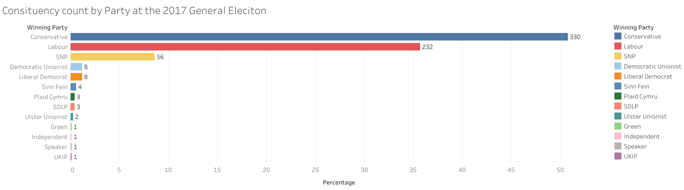

*(Bubble chart showing Conservative/Labour dominance and SNP’s regional strength in Scotland)*

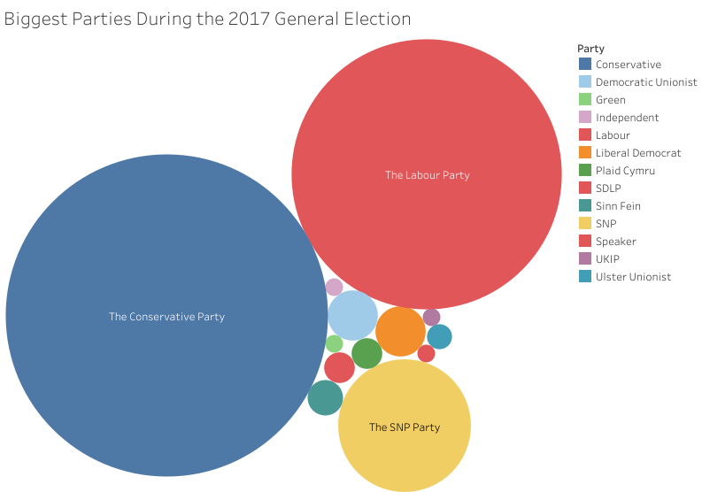

**TO ADD TOTAL VOTES AND PERCENTAGE VOTES**

### **Research Question 2: Brexit Referendum Correlation**

**Remain Constituencies**:

* **Labour**: 76.7% of their seats (178/232)
* **Conservatives**: 33.9% (112/330)
* **SNP**: 98.2% (55/56)

**Leave Constituencies**:

* **Conservatives**: 66.1% (218/330)
* **Labour**: 23.3% (54/232)
* **SNP**: 1.8% (1/56)

**Key Insights**:

* Labour’s support was concentrated in Remain areas, while Conservatives dominated Leave constituencies.
* The SNP’s near-total absence from Leave areas underscores the party’s pro-EU stance.
* Remain constituencies are more likely to swing vote to different parties.

**Visual**:  
Dashboard of all visuals below - <https://public.tableau.com/app/profile/olly.de.ber/viz/LeaveRemainAnalysis/Dashboardofanalysis?publish=yes>

*(Dual bar chart comparing party performance in Remain vs. Leave areas)*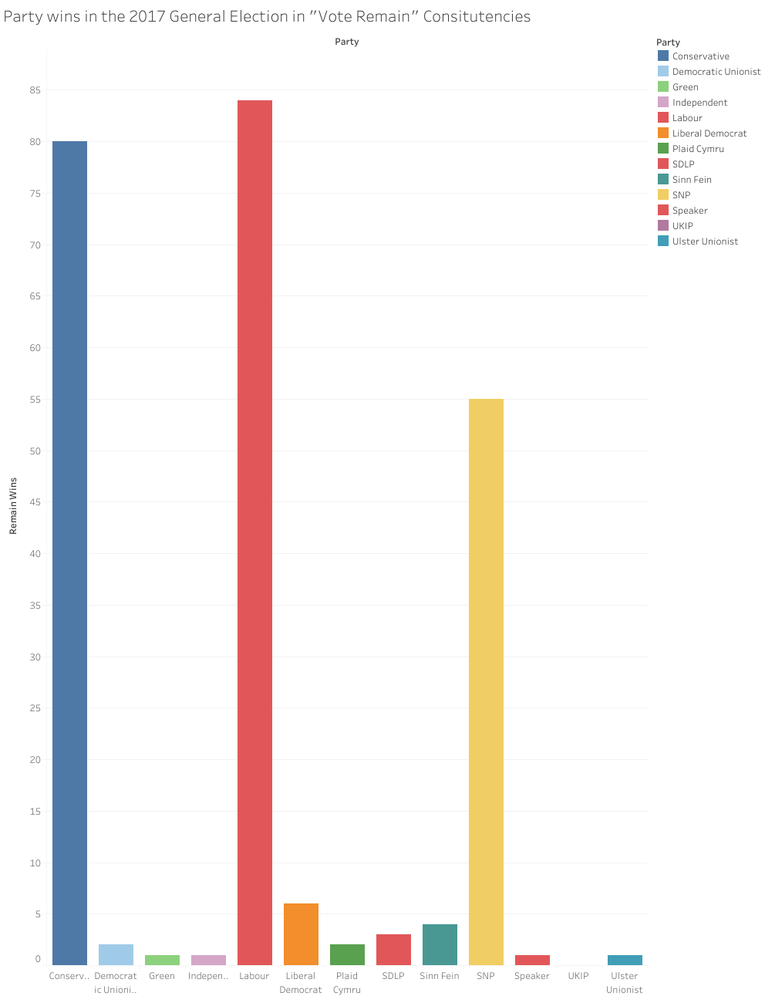

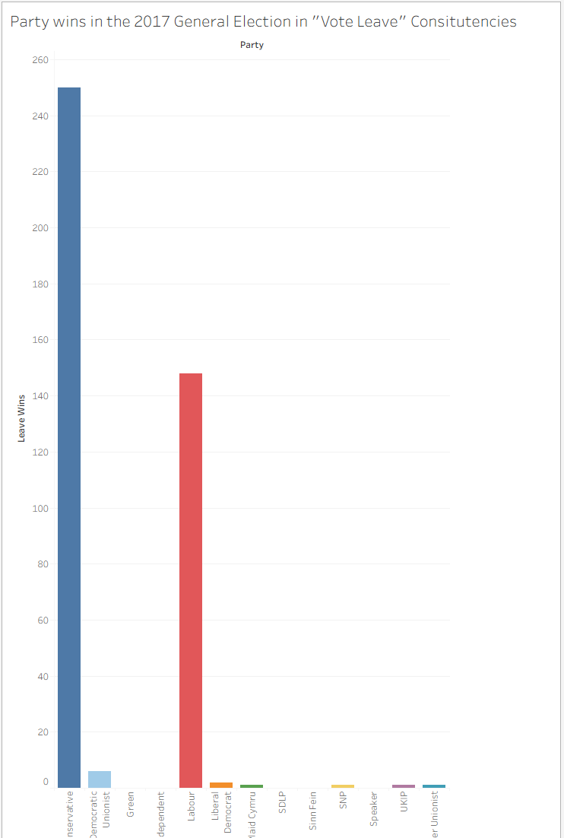

The Pie Chart below shows a another visualisation of the insights.

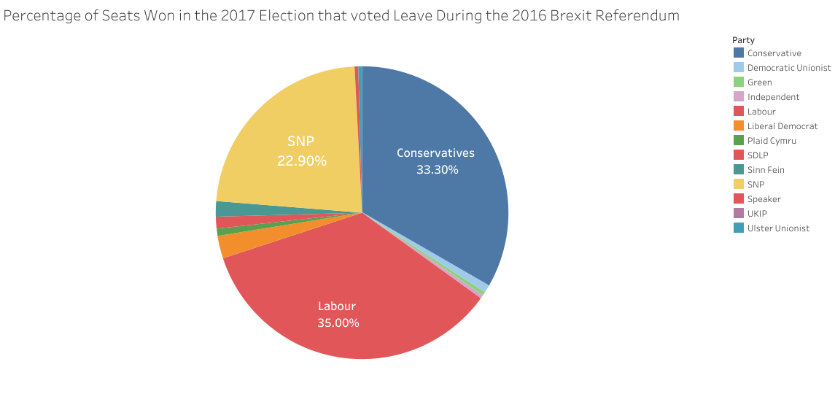

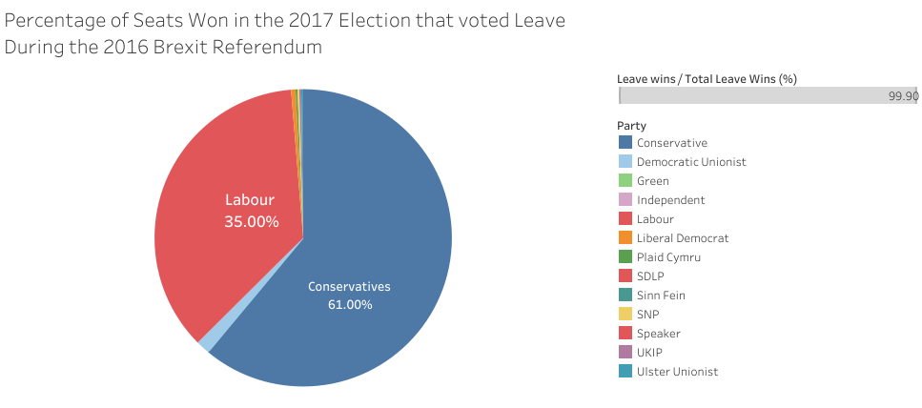

Further questions from this analysis could be drawn, such as “Of constituencies that voted leave, how many were in Cities ?”. **Could include?**

### **Research Question 3: Top 5 Largest Majorities**

**Labour Strongholds**:

1. Knowsley (34,655 majority)
2. East Ham (34,252)
3. Bootle (28,704)

**Conservative Strongholds**:

1. North East Hampshire (32,000+)
2. Maidenhead (31,000+)

**Analysis**:

* Labour’s safest seats had larger margins than Conservative strongholds, suggesting deeper voter loyalty in core areas.
* SNP’s majorities were smaller (top: Glasgow East, 10,387), indicating more competitive seats.

**Visual**:

Conservative top 5 Table - <https://public.tableau.com/app/profile/olly.de.ber/viz/ConservastiveTop5table/Sheet1?publish=yes>

Labour top 5 Table - <https://public.tableau.com/app/profile/olly.de.ber/viz/LabourTop5Table/LabourTop5?publish=yes>

SNP top 5 Table- <https://public.tableau.com/app/profile/olly.de.ber/viz/SNPtop5Table/Sheet1?publish=yes>

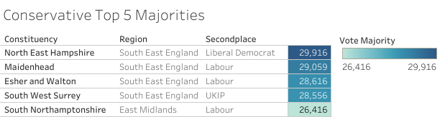

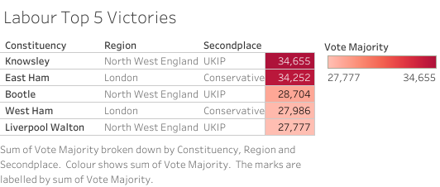

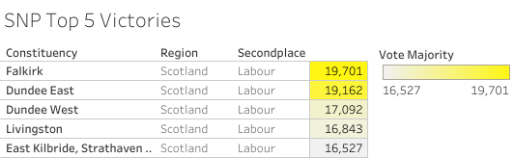

### **Research Question 4: Closest Marginal Seats**

**Top 5 Narrow Wins**:

1. Gower (Con win by **27 votes**)
2. Derby North (Con by 43)
3. Croydon Central (Con by 165)

**Strategic Implications**:

* These constituencies are prime targets for opposition parties in future elections.
* Gower’s 27-vote margin is within recount territory, highlighting extreme volatility.

**Visual**:  
<https://public.tableau.com/app/profile/olly.de.ber/viz/ClosestMajorities/ClosestMajority?publish=yes>   
*(Map highlighting tight races with tooltips showing vote differences)*

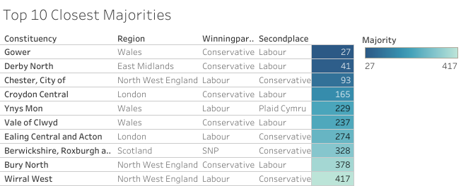

### **Research Question 4: Regional Breakdown**

**Top 3 Strongest Performance Regions for the Conservatives**:

1. South East England
2. East of England
3. South West England

**Top 3 Strongest Performance Regions for Labour**

1. North West England
2. London
3. Yorkshire and the Humber

**Strategic Implications**:

* Labour continues to perform better in Northern England, London, Wales and the West Midlands
* The Conservatives dominate the South and East of England

**Visual**:  
<https://public.tableau.com/app/profile/olly.de.ber/viz/RegionalVisualisation/Sheet1?publish=yes>   
*(Map highlighting tight races with tooltips showing vote differences)*

